HIGHWAY IMPROVEMENT PLAN – Stage 1 – (Parish Council to list with as much information as possible and in priority order their issues and then send to KCC contact ). |  |  | ACTION PLAN – Stage 2 (to be completed by KCC contact and regular updates provided to the Parish Council)
Priority | Location | Problem & Potential solution (if known) | Action/Programme  (Who/When) | Cost Estimate | Funding Source | KCC Comments
1.  HIGH | The Street, from entry gateways  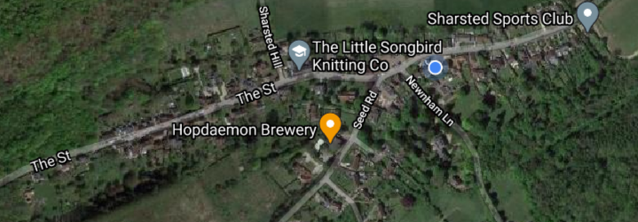 | Problem: Speeding vehicles through the village throughout the day (not just peak times).  Solution: Parish speed indicator device |  | £7,000 confirmation awaited from KCC | Parish Council
2.  HIGH | The Street, from entry gateways | Problem: Speeding vehicles through the village.  20MPH scheme supported by residents setting up 20’s Plenty for Newnham
3.  HIGH | Salt Bin, just of Frith Road  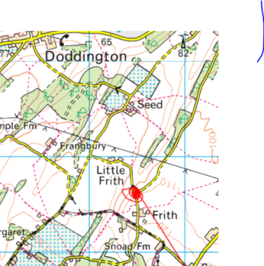 | Problem: Salt bags are left in the hedges  Solution: a salt bin |  |  | Parish Council
4.  HIGH | Wineycock, off Seed Road (red dot location)  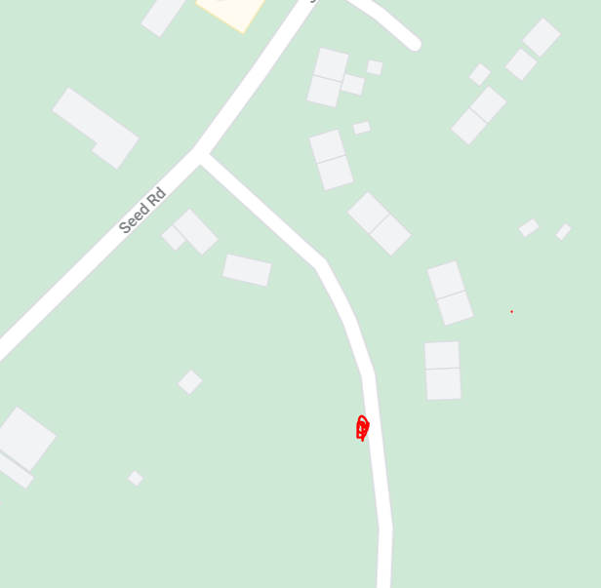 | Problem: Salt bags are left in the hedges  Solution: a salt bin |  |  | Parish Council
5.  HIGH | Reduction from NSL to 30mph between Newnham and Doddington villages  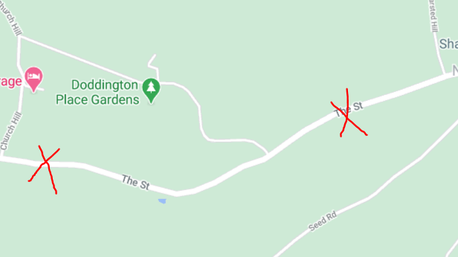 | Problem: Speeding vehicles entering the village  Solution: reduction of speed between the two villages
6.  MEDIUM | Park House, The Street, Newnham  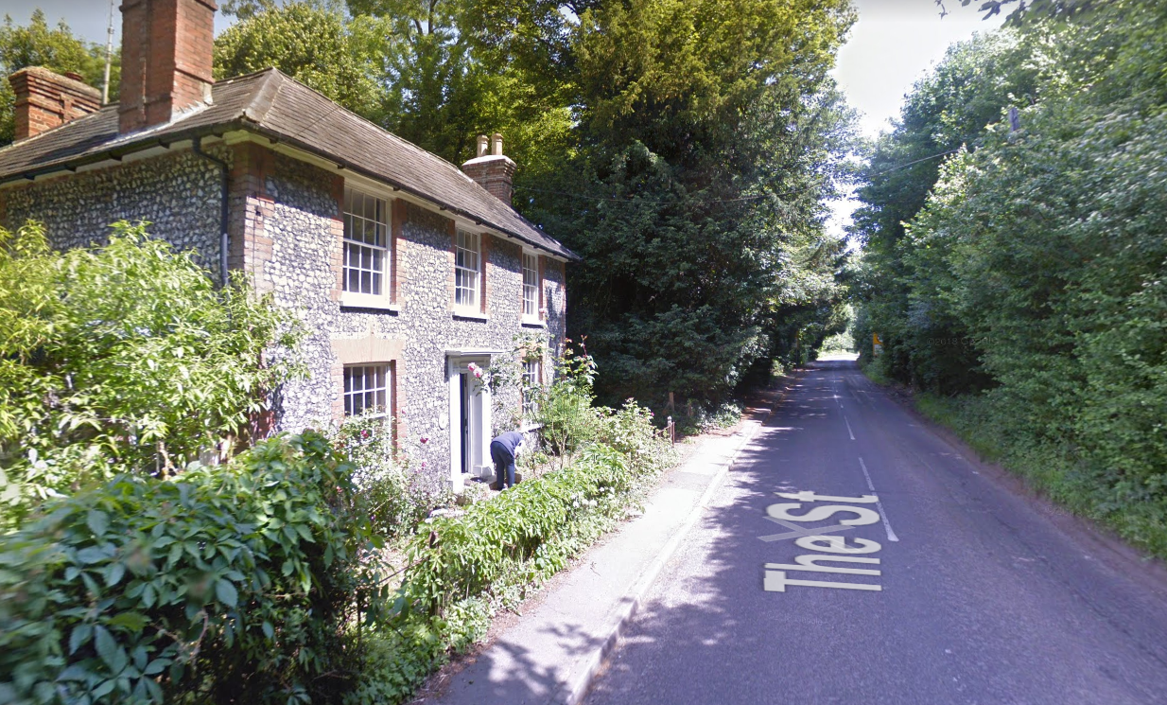 | Problem: Flooding to Park House due to village entry buildout blocking the free fall of rainwater to the next gulley.  Solution: Cleaning of gulleys, raising kerb outside Park House, clearing leaves from footpaths
7.  MEDIUM | 2-10 The Street, Newnham  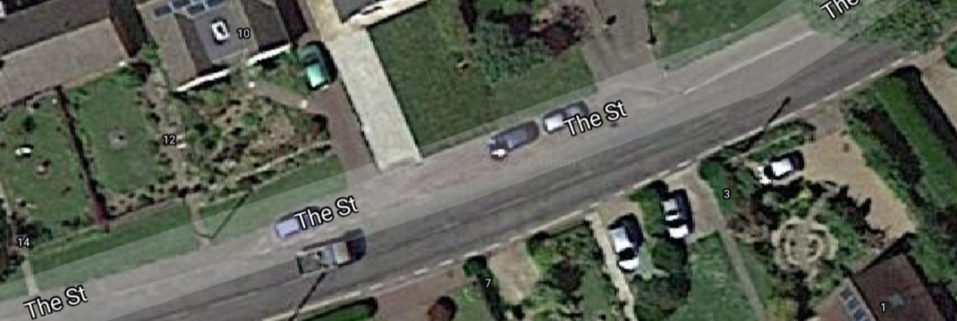 | Problem: Flooding to layby and road  Solution: Clearing away of mud residue and cleaning of gulleys
8.  MEDIUM | Foxenden Lane, off Wineycock  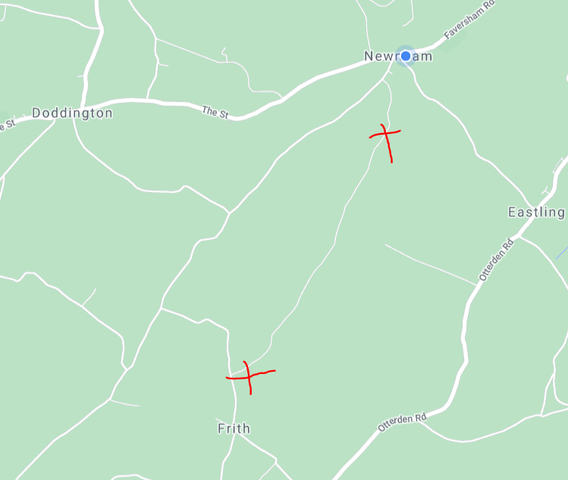 | Problem: Road un-driveable due to potholes, mud and flints the full length  Solution: Clean road and fill potholes

